Post lab
Using the same hotels database as created in Lab 5, write SQL statement along with output to answer following queries:
- Give the name(s) of guest who have booking both for Watergate or Latham hotel.
select g.guestname
from guest g inner join booking b on g.guestno = b.guestno
inner join hotel h on b.hotelno = h.hotelno
where h.hotelname = 'Watergate'
intersect
select g.guestname
from guest g inner join booking b on g.guestno = b.guestno
inner join hotel h on b.hotelno = h.hotelno
where h.hotelname = 'Latham'

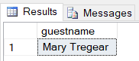

- Give the name(s) of guest who have booking either for Watergate and Latham hotel.
select distinct g.guestname
from guest g inner join booking b on g.guestno = b.guestno
inner join hotel h on b.hotelno = h.hotelno
where h.hotelname = 'Watergate' or h.hotelname = 'Latham'

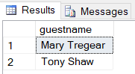

- Give the name(s) of guest who have booking for Latham but not for Watergate hotel.
select g.guestname
from guest g inner join booking b on g.guestno = b.guestno
inner join hotel h on b.hotelno = h.hotelno
where (h.hotelname = 'Latham') and g.guestname not in
(
select g.guestname
from guest g inner join booking b on g.guestno = b.guestno
inner join hotel h on b.hotelno = h.hotelno
where h.hotelname = 'Watergate'
)

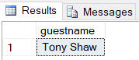

- Display the name of the guest who has stayed in maximum number of hotels
select g.guestname
from booking b inner join guest g on b.guestno = g.guestno
group by b.guestno, g.guestname
having count(distinct b.hotelno) =
(
select max(sc.StayCount)
from
(
select count (b.hotelno) StayCount
from booking b
group by b.guestno
) sc
)

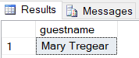

- Display the name of the hotel with as many rooms as Latham hotel
select h.hotelname
from room r inner join hotel h on r.hotelno = h.hotelno
where h.hotelname <> 'Latham'
group by r.hotelno, h.hotelname
having count(*) =
(
select count(*) RoomCount
from room r inner join hotel h on r.hotelno = h.hotelno
where h.hotelname = 'Latham'
group by r.hotelno
)

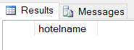

- Display the name of the hotel with the cheapest room
select h.hotelname
from room r inner join hotel h on r.hotelno = h.hotelno
where r.price =
(
select min(r.price)
from room r
)

